1) How to save only last 5 builds of jenkins job?
When you install a Jenkins it has a .jenkins folder in background where the file system of Jenkins (all our build information, configuration of your job, and configuration of your Jenkins everything will be saved there only) is gone saved in that, let say one project is there from last 2 years every one build for every day that means more than 700 builds so keeping like those many hold build it doesn’t make any sense in those cases depending on client requirement you can hold last 5 specified builds by this you can take of the memory by used this build file. 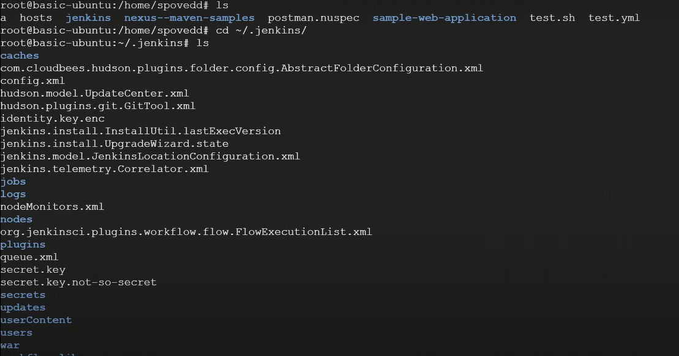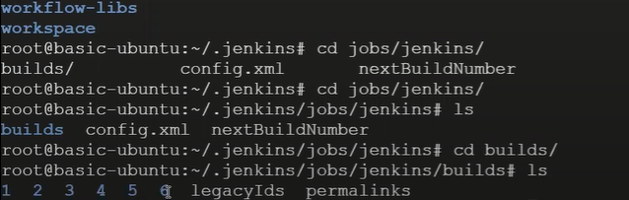for one job (name=Jenkins) it has 6 builds
You can save only last 5 builds so you can save a memory in your Jenkins host
(J)Jenkins – configure – general => Discard old Builds 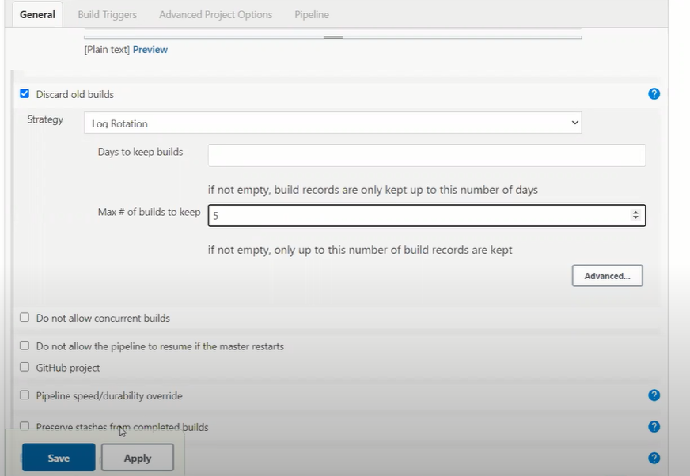
2) Have you worked on Jenknsfile? Can we use docker container as a node in Jenkinsfile? Who will handle docker container creation and deletion? If I am building a maven project always docker container is fresh instance it will try to download dependency from repository, what measures you will take to reduce build time? (Jenkinsfile – branch (develop) – Jenkinsfile)
Yes, the container creation and deletion handle by Jenkins itself, it automatically creates the container on top of that container it will gone do the build, once the build done the container will be deleted.
pipeline{
agent {
docker {
image 'maven'
args '-v /root/.m2:/root/.m2' ## when you run it for second time it should reduce the build time
}
}
parameters {
choice(name:'mvnaction',
choices: 'Clean\nCompile\nTest\nInstall',
description: 'based on selection jenkins will run resepective maven command')
}
stages{
stage('build')
{
steps{
script{
sh "mvn --version"
sh "echo $mvnaction"
if ("${mvnaction}" == "Clean")
{
sh "mvn clean"
}
else if ("${mvnaction}" == "Compile")
{
sh "mvn clean compile"
}
else if ("${mvnaction}" == "Test")
{
sh "mvn clean test"
}
else if ("${mvnaction}" == "Install")
{
sh "mvn clean install"
}
} } } } }
When you check with the logs it started docker container at the beginning of the execution 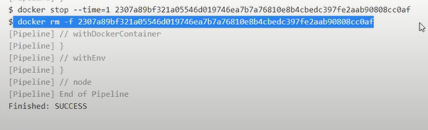
Next to reduce build time 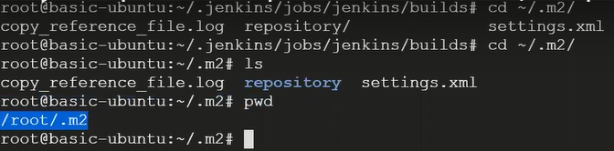
All this repository copied to the container then it use this dependency as local repository of container
3) Why we need multi branch pipeline?
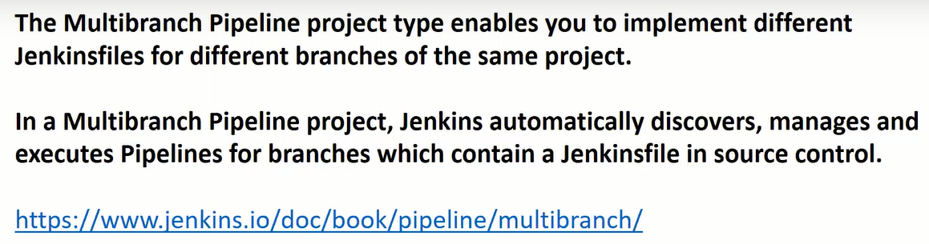
multibranch very important job type in this day’s, it will create each job for each branch and each branch should have Jenkins file
4) If you forget Jenkins password, how would you login back?
Jenkins will be running on some machine right so basically that will have backend file system 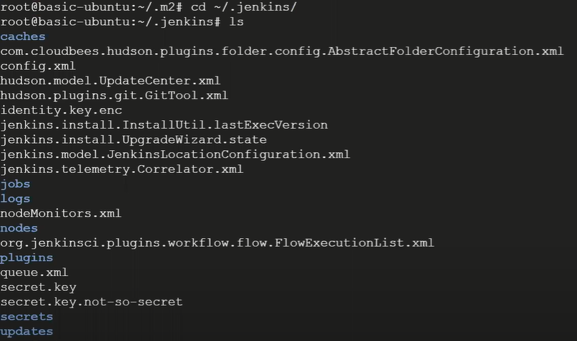
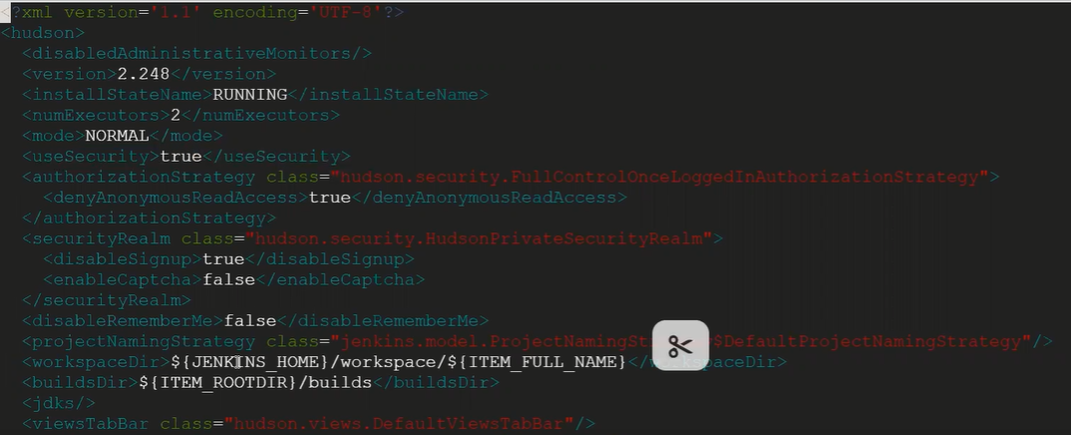
By default <useSecurity>true</useSecurity> make it as false
It will not shoe the login page direct access, then you set the password
( to list all active process ps –eaf and identify Jenkins processes id and kill that process { kill -9 PID} 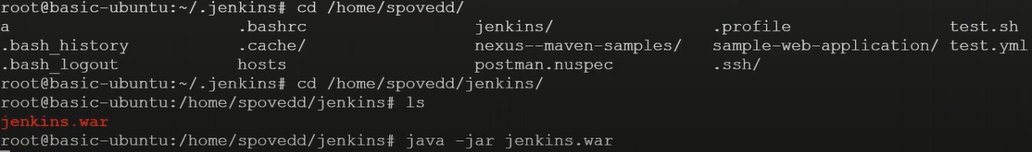
login back to Jenkins ip:8080 it will not show login page direct access )

5) Have you worked on commit based job in jenkins? what settings you need to do in jenkins and github to setup commit based job?
-- Whenever anyone commits particular repo it should trigger a job Jenkins
(In repo - - Settings – Webhooks – add webhook – github password) 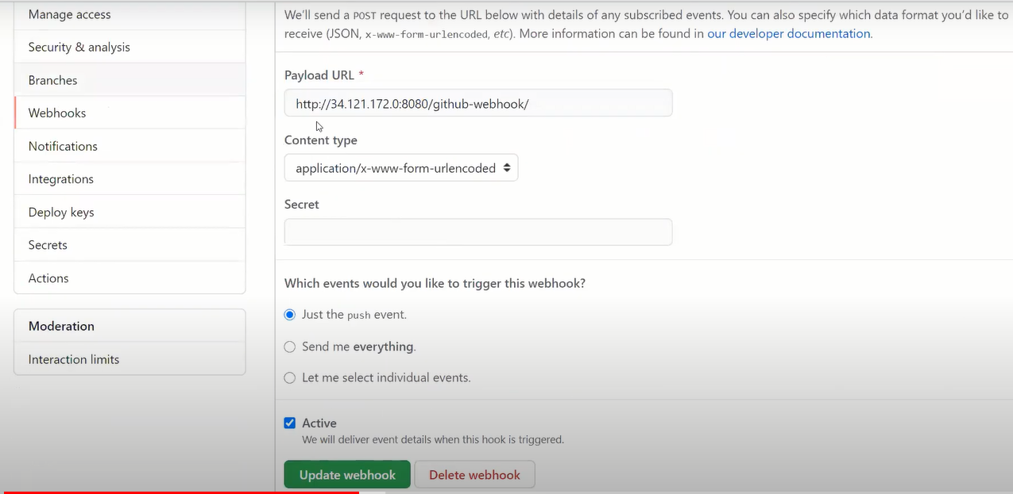
When you add this a green tic mark see 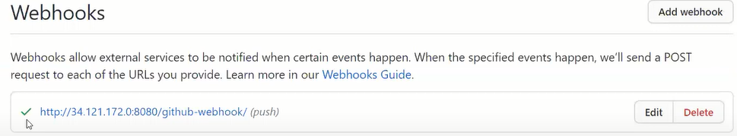
In Jenkins job => 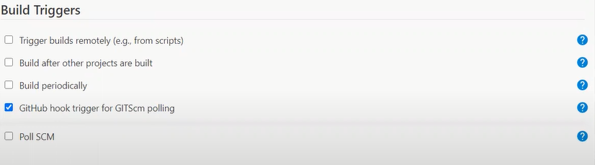
6) you want to create 50 freestyle jobs with same configurations, but only change is job name. how would you achieve the same? ( repo ( Jenkins) → dsl-script-pipeline )
ans - - Manage Jenkins → script Console → run ( it will create a New Job )
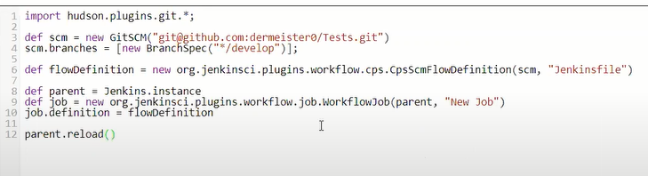

7) How can you copy job from your local jenkins instance to other local jenkins instance?
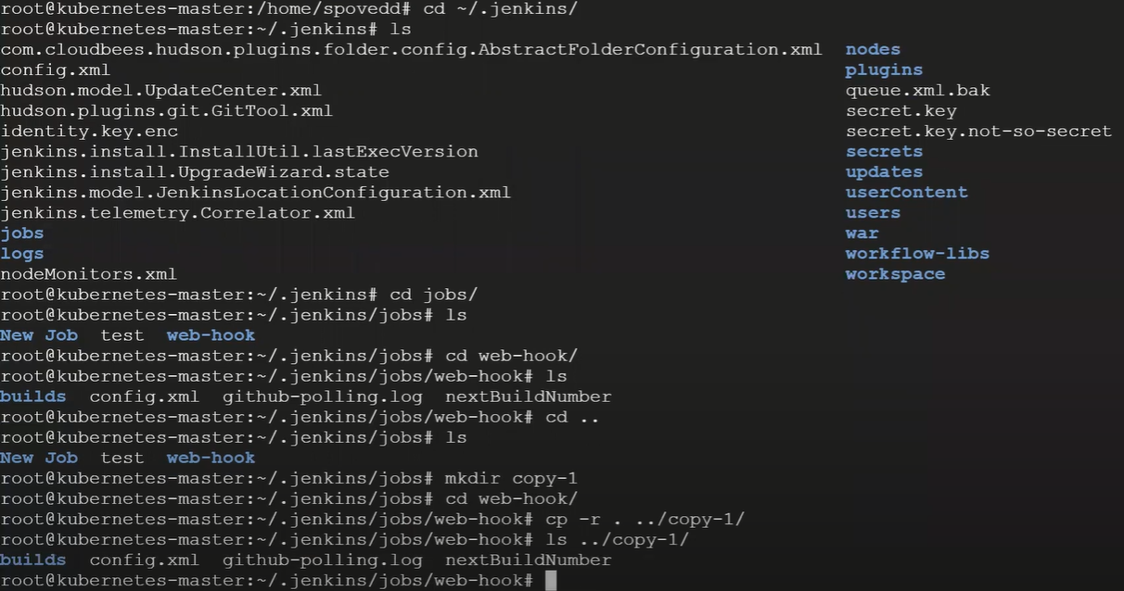
Then go back to Jenkins → ManageJenkins → Reload Configuration from Disk → ok
one more job is cameup that is copy-1

8) How to Downgrade plugins in Jenkins?
I have couple of plugins which already installed
ManagePlugins → Available → click on the link of plugin → Releases → download the specific version
Come back to ManagePlugins → Advenced → Deploy Plugin → choose downloaded version → Deploy
And also there are any other ways

9) Have you worked on Jenkinsfile? Can we use different nodes for each stage?
Yes I used declarative syntax next question ( repo (Jenkinsfile) → branch (multipleContainer) → Jenkinsfile)
pipeline{
agent none
stages{ stage('front-end’) {
agent {
docker {image 'node'}
}
steps{
script{
sh 'node --version'
}
}
}
stage('backend') {
agent {
docker {image 'maven'}
}
steps{
script{
sh 'mvn --version'
}
}
}
}
}
10) Can you list few ways by which we can trigger our build in Jenkins? What is the difference between Build Periodically and Poll SCM? 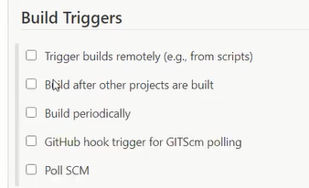
Both are working in cronjob formate
Poll SCM periodically check whether changes were made (i.e. new commits) and builds the project if new commits where pushed since the last build, whereas build periodically builds the project periodically based on cronjob format even if nothing has changed.
11) How to set Jenkins build to fail based specific word in console output ?
Repo (CICD_Java_gradle_application) → JenkinsfileFilter
pipeline {
agent {
docker {
image 'openjdk:11'
}
}
stages {
stage('Building') {
steps {
sh 'chmod +x gradlew'
sh "./gradlew build | tee output.log"
}
}
stage('Monitoring the logs') {
steps {
script {
sh '! grep "WARNING" output.log'
}
}
}
}}
12) What are active and reactive parameters (Dynamic parameterization) in Jenkins ?
Install plugin → Active Choices Plug-in
Depending on one drop down change, I want to change the parameter in other dropdown.
Enable this project is parameterized → you will get a Add Parameter (drop down)→ select active choice parameter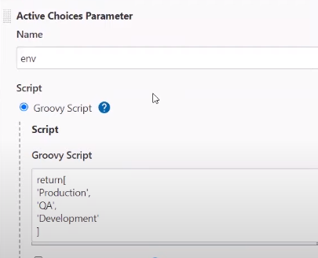
other options I am not touching and once it is don again Add Parameter (drop down) → 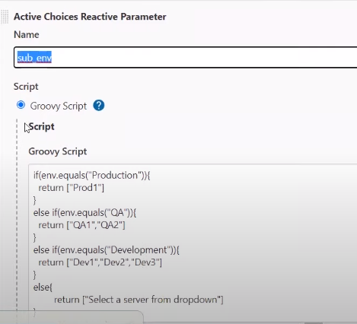 in Referenced parameter env
once it is don again Add Parameter (drop down) → → Active Choice Reactive Parameter – name is
machine
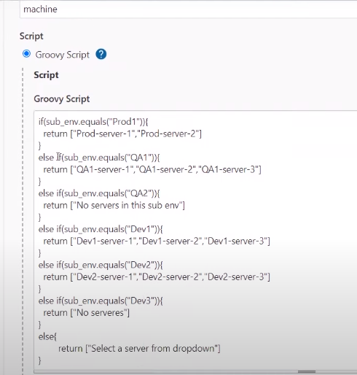 in Referenced parameter sub_env then click on save

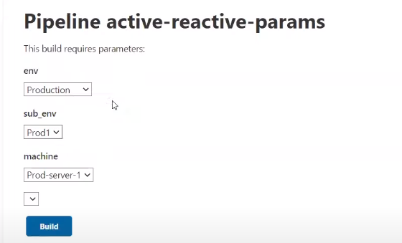

13) How to customize the build number display to something else in Jenkins job page?
( Pipeline Syntax → Global Variable Reference)Under currentBuild variable you have displayName & number variables
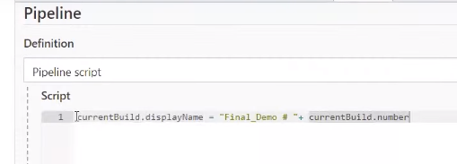
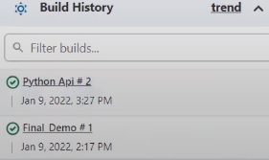
14) What are multi branch pipeline? (repo (CICD_Java_gradle_application) → so many branches)
We will create multibranch pipeline because you have a git hub repo in that there are so many branches you want to build each branch that means each branch is identified by the Jenkins and it has to build, in that case you go for multibranch pipeline & mandatory is each branch should have a jenkinsfile if it is not there in that case job won’t be created for that particular branch

15) What is shared library in Jenkins ?
Let say few lines of code there in the pipeline which are repeated in many of the Jenkins file rather then just keeping it in all the pipeline in jenkinsfile just keep those line in centralized place and you can refer it whenever you want through this your maintainability will more because if you want to update any code in the repeated line it should applicable for all the jenkinsfile

Practical -> Configure System → Global Pipeline Libraries 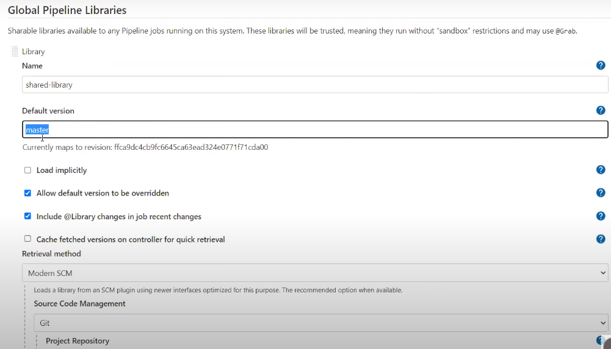
Name & version specify and also given the git repo where my shared library is there (repo (shared-library)→ you need to maintain the folder structure in that )
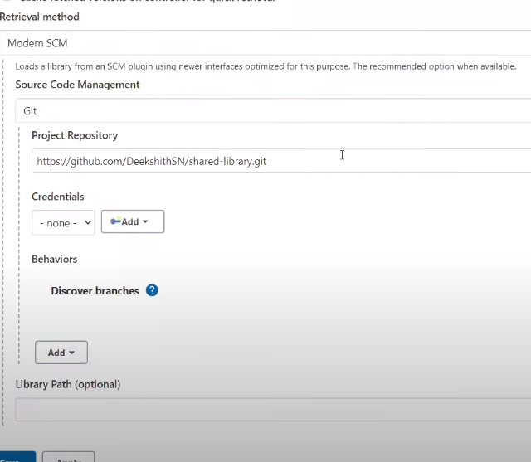

#!/usr/bin/env groovy (repo – CICD_Java_gradle_application → JenkinsfileSharedLibrary)
@Library('shared-library@master') _ //master or whatever branch
pipeline {
agent {
docker {
image 'openjdk:11'
}
}
stages {
stage('Building') {
steps {
sh 'chmod +x gradlew'
sh "./gradlew build "
}
}
stage ('Check logs') {
steps {
filterLogs ('Task', 15) # when ever task more then 15 times in console make job as ubstable
}
}
}
}
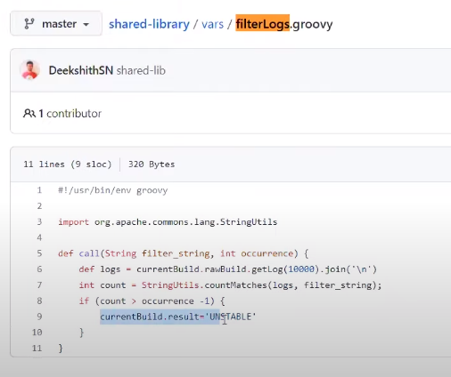
16) what is the need of CICD tools?
17) What type of Jenkinsfile you have worked on?
* Free style
* Pipeline ------ Scriptive and declarative syntex
* Multipipeline

18) In master slave setup if I want run job on specific node is it possible?
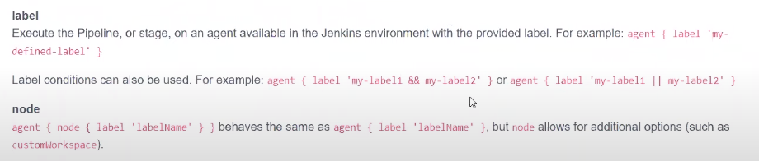
In that case you need to specify agent and label, when you attach a slave node it will gone a ask you what should be a label of your slave node
19) what is the importance of Jenkins secrets?( repo [CICD_Java_gradle_application]→ Jenkinsfile)
Where you are working on a pipeline and you want to use docker password to authenticate you should ant show in logs also and jenkinsfile also that’s where your using Jenkins secret 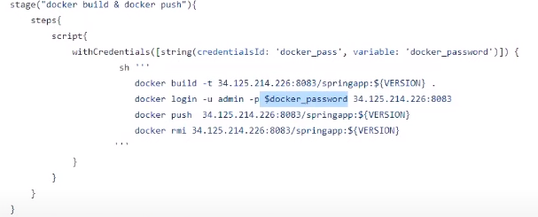
Manage Jenkins → Manage Credentials → Jenkins → Globalcredentials → add credentials → 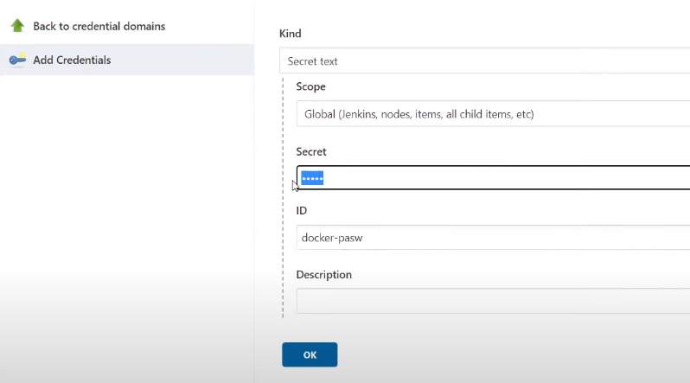
Basically you hiding sensitive information both the logs and jenkinsfile also

20) What are types jobs you have worked on??( CICD_Java_gradle_application→ wiki)
21) Can we have job for pr and once merge is done the source branch should be deleted?
(https://www.youtube.com/watch?v=adG0vq5boL8&t=478s) – 3h
Whenever you want to change the port in real time project you never do changes directly on base branch you will create a new branch do the changes and rise the pr, what ever the changes that you made you should take the changes and just build that code in the Jenkins and check that new changes either breaking my older code or not so for that whenever you rise a pr the job actually trigger in the Jenkins once approval is done merge back to base branch 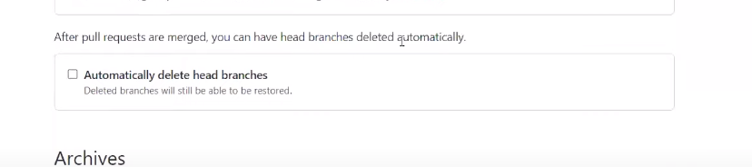
22) How do you take Jenkins backup?
There are so many ways you can use plugin for that one of the way I have used to take backup
Plugin → ThinBackup plugin install
- ManageJenkins → ThinBackup → 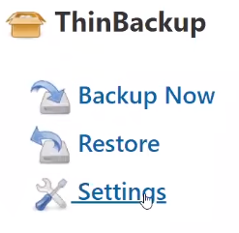→ what all the setting you will going to provide based on it will try take the backup
( when you run a Jenkins there will be definitely .jenkins folder it will be tar or copy to some other location/ directory or if you have nfs mounting all you copy that file into NFS machine soo even if this Jenkins goes down you have backup of .jenkins folder )
- You can take the backup by shellscripts also use cronetab processes to take the back for every 10 minutes and keep it in some folder
23) Can you tell me importance of post block??

In the Jenkinsfile once the stage execution is done if you want to do little clean up activity like you want to send a email to enter team if job is success or any failure you want to do any activity or trigger next job soo those kind of thing you do it in post job, in real time every time once the job is done clean your workspace so that like you removing older port like whenever you do next trigger, code will freshly clone that code will be executed if you don’t clean up code will be setting up on your Jenkins and also it consumes space in a Jenkins

